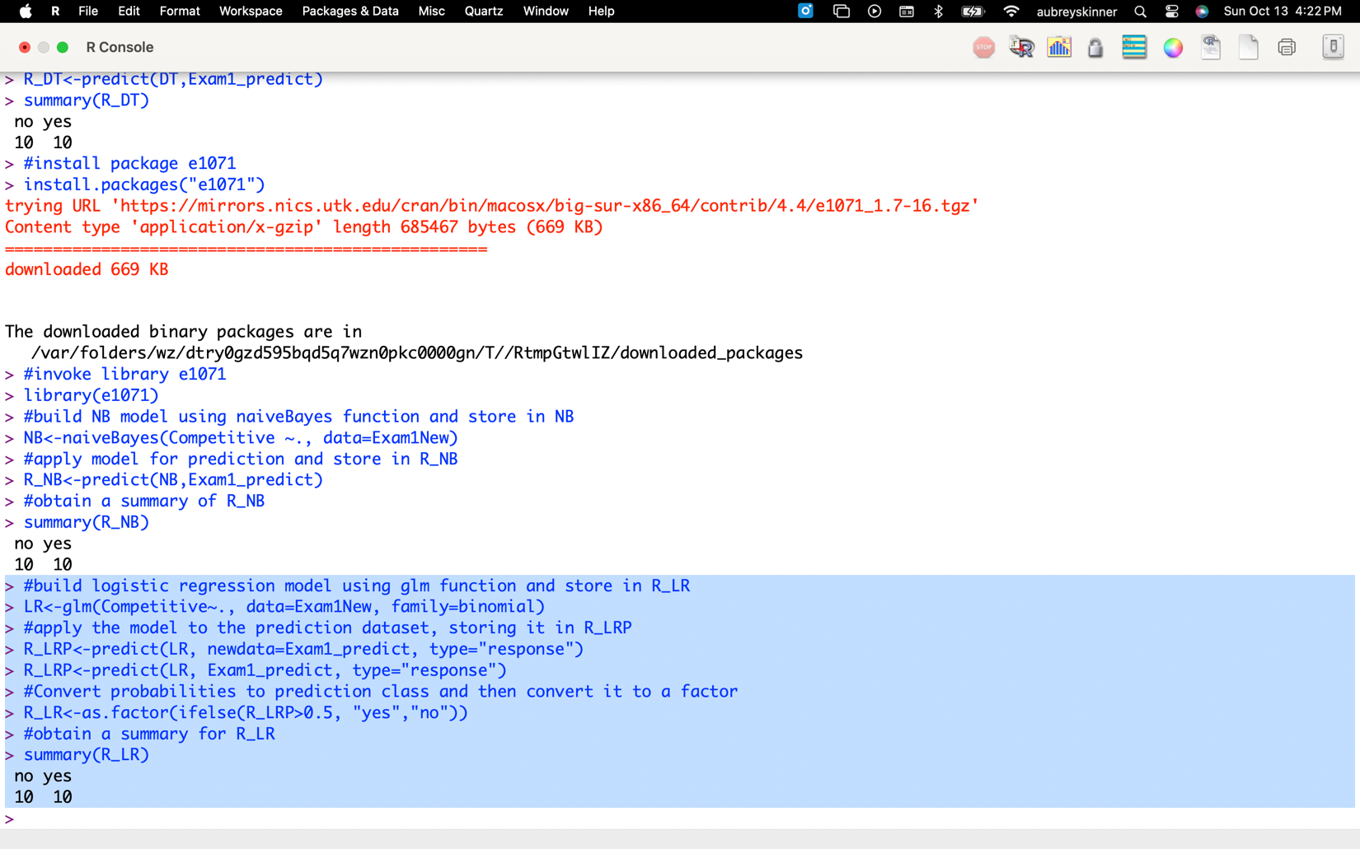

|  |  |  |  |  |  |  |  |  |
| --- | --- | --- | --- | --- | --- | --- | --- | --- |
| id | RM_DT | RM_NB | RM_LR | RM_NN | R_DT | R_NB | R_LR | R_NN |
| 1 | no | no | no | no | no | no | no | no |
| 2 | yes | yes | yes | yes | yes | yes | yes | no |
| 3 | yes | yes | yes | yes | yes | yes | yes | yes |
| 4 | yes | yes | yes | yes | yes | yes | yes | yes |
| 5 | yes | no | no | yes | no | no | no | no |
| 6 | yes | yes | yes | no | yes | yes | yes | yes |
| 7 | no | no | no | no | no | no | no | no |
| 8 | yes | no | yes | yes | yes | no | no | yes |
| 9 | no | no | no | yes | no | no | no | yes |
| 10 | yes | no | yes | yes | yes | no | no | no |
| 11 | yes | yes | yes | yes | yes | yes | yes | yes |
| 12 | yes | yes | yes | yes | no | yes | yes | yes |
| 13 | yes | no | no | no | no | no | no | yes |
| 14 | yes | no | no | yes | no | no | no | yes |
| 15 | yes | yes | yes | yes | yes | yes | yes | yes |
| 16 | yes | yes | yes | yes | yes | yes | yes | no |
| 17 | no | no | no | no | no | no | no | no |
| 18 | yes | yes | yes | yes | no | yes | yes | yes |
| 19 | yes | yes | yes | yes | yes | yes | yes | yes |
| 20 | no | no | no | yes | no | no | no | no |

**RM_DT and R_DT:** This method jointly predicted “yes” for 10 records (ID = 2, 3, 4, 6, 8, 10, 11, 15, 16, and 19), and jointly predicted “no” for 5 records (ID = 1, 7, 9, 17, and 20).

**RM_NB and R_NB:** This method jointly predicted “yes” for 10 records (ID = 2, 3, 4, 6, 11, 12, 15, 16, 18, and 19), and jointly predicted “no” for 10 records (ID = 1, 5, 7, 8, 9, 10, 13, 14, 17, and 20).

**RM_LR and R_LR:** This method jointly predicted “yes” for 10 records (ID = 2, 3, 4, 6, 11, 12, 15, 16, 18, and 19), and jointly predicted “no” for 8 records (ID = 1, 5, 7, 9, 13, 14, 17, and 20).

**RM_NN and R_NN:** This method jointly predicted “yes” for 10 records (ID = 3, 4, 8, 9, 11, 12, 14, 15, 18, and 19), and jointly predicted “no” for 3 records (ID = 1, 7, and 17).

All eight models jointly predicted “yes” for 5 records (ID = 3, 4, 11, 15, and 19), and “no” for 3 records (ID = 1, 7, and 17).